**Topic 8: Asset Allocation and Portfolio Management**

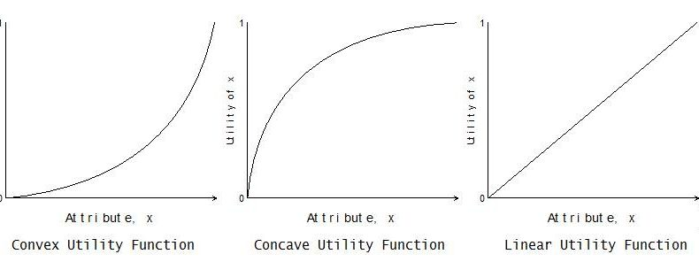

* Buy-and-hold
* Concave payoff curves
* Constant mix
* Constant-proportion portfolio insurance
* Convex payoff curves
* Decision rule
* Exposure diagram
* Floor
* Multiplier
* Option-based portfolio insurance

Dynamic Strategies for Asset Allocation Perold and Sharpe



**1. Calculate the portfolio’s asset values after a given change in the equity value,**

**using:**

a. buy-and-hold. (linear)

Linear equation. Y= mx + b

b. constant mix. (concave)

* Purchase stocks when they fall in value. Sell stocks as they rise in value.
* “Jump off the train”
* Constant mix policy tends to be superior if markets are characterized more by reversals than by trends.
* Maintain an exposure to stocks which is constant with their wealth

c. constant-proportion portfolio insurance. (CPPI)

* Constant Proportion Portfolio Insurance (CPPI) allows an investor to maintain exposure to the upside potential of a risky asset while providing a capital guarantee against downside risk.
* The outcome of the CPPI strategy is somewhat similar to that of buying a call option but does not use option contracts. Like a Call OPTION.
* Dollars in stocks = (Assets – Floor)
* CPPI strategy sells stocks as they fall and buys stocks as they rise. “Jump on the train” – Trending markets.
* Investor selects the multiplier and a floor below which he does not want the portfolio value to fall.

**2. Compare the payoff and exposure diagrams of the**

buy-and-hold

* LINEAR
* This diagram is simply a straight line with a slope.
* 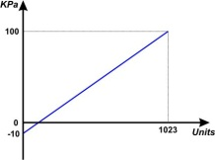

constant mix

* CONCAVE - You want FLAT and OSCILLATING markets
* constant rebalancing is occurring. So, you will get a curved payoff diagram.
* Concave is better in flat and oscillating markets
* 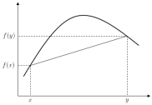

constant-proportion portfolio insurance (CPPI)

* CPPI. Investor selects the multiplier and a floor below which he does not want the portfolio value to fall. This floor grows at the rate of return on bills and must initially be less than total assets.
* Constant Proportion Portfolio Insurance or CPPI products are capital guarantee product based on a dynamic asset allocation strategy. The strategy actively allocates between two asset classes - a riskless asset and a risky asset which could be from equity, hedge funds, funds, equity or commodity indices etc.
* In rising markets, the strategy allocates more towards the risky asset while in falling market, the strategy allocates more towards the safe asset. Like buying high, selling low.
* CPPIs are also one of the most popular derivative products because of their capital protection feature. Although CPPIs were first developed for the retail investors, they are now popular even with pension funds and insurance companies as the structure still ensures minimum future cash flow required by these industries.
* CPPIs are sometimes compared to a bond + a call option capital protected strategy
* CPPIs are negative gamma products for the buyer. To replicate the product, one would be buying the risky asset in the rising markets while selling in falling markets i.e. buying high and selling low.

option-based portfolio insurance strategies. (OBPI)

* CONVEX – like a call
* (OBPI) insurance: strategies implicitly involve a floor value at every time prior to the horizon.
* Payoff diagram looks just like a CALL OPTION.
* 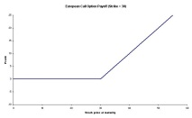

**3. Determine the expected performance and cost of implementing strategies with concave payoff curves relative to those with convex payoff curves under:**

a. trending markets

Sell stocks as they fall. Gives rise to convex payoff curves that do well in trending markets. A strategy where past winners are purchased, and past losers are sold.

b. flat (but oscillating) markets

Strategies that buy stocks as they fall give rise to concave payoff curves. They do will in flat (oscillating markets). Don’t have much downside protection.

**4. Discuss the motivations for and impact of resetting the parameters of dynamic strategies.**

* With option-based portfolio insurance, one has no choice but to reset at the horizon.
* There is no reason to believe that any particular dynamic hedging is the best.

1) Rolling the horizon

2) Resetting the end of horizon floor so as to keep it in constant proportion to assets is also just a constant mix strategy in disguise.

Smoothing and Implications for Asset Allocation Choices Marcato and Key

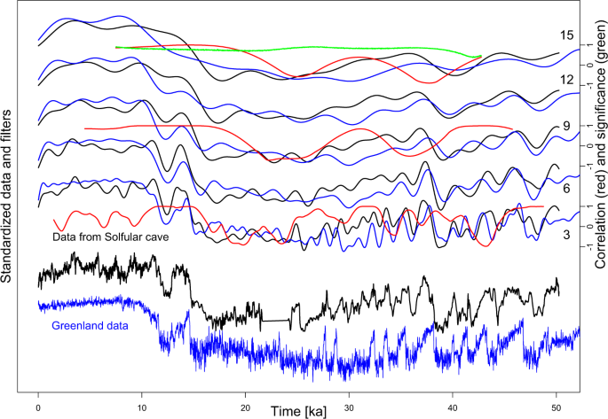Note: “Smoothing”

* First Order Autoregressive Reverse

Filter (FOARF)

* Full Information Value Index (FIVI)
* Second Order Autoregressive Reverse Filter
* Smoothing

**1. Describe the three factors that cause smoothing and how smoothing impacts asset allocation decisions.**

Smoothing is the phenomenon that causes a lag effect and reduced volatility in valuation based indices in comparison with the underlying market which is represented by accurate transaction based indices.

Three main factors may cause smoothing in a valuation-based index.

1. The Aggregation process underlying the index construction. Getting rid of outliers.
2. Temporal Aggregation: Time of Valuations spread over time
3. Inertia in individual valuations arising from anchoring to prior values in the absence of conclusive current market evidence, on in other words, thresholds applied by values before a change in value is reported.

**2. Compare the results of Stevenson (2004) with previous studies on the impact of smoothing models on allocations to real estate.**

* Stevenson finds NO DIFFERENCE in the application of two different unsmoothing methods; other research found that model selection has a significant impact on real estate weights.

**3. Compare Four approaches to generating an unsmoothed total real estate return series.**

1. FOARF. First Order Autoregressive Reverse Filter. Includes the capital growth return from the prior period and the lagged return adjusted by a constant unsmoothing parameter.
2. Second Order Autoregressive Reverse Filter (AR2). Includes the first TWO LAGS to unsmooth the data.
3. FIVI: Full Information Value Index. A first order autoregressive specification to obtain a full information value index. This is a first order autoregressive model that uses the volatility of residuals to compute the weights used in calculating the unsmoothed capital rate.
4. Same as FOARF but allowed to change: First Order A Filter with Growth States (i.e. STATES). This is similar to FOARF except that the unsmoothing parameter is allowed to change depending on the STATE of the market.

**4. Describe the impact of varying smoothing parameters for UK real estate return data on the optimal allocations to real estate.**

* The amount of real estate allocated to a portfolio is very sensitive to the unsmoothing parameter
* CALIBRATION of smoothing parameter is much more important than model selection.
* More Allocation to Smooth

**5. In the Marcato and Key (2007) study compare and contrast the results of using**

**UK data with those employing US and Australia real estate return data.**

  

1. The unsmoothing parameter had a large impact to the overall portfolio weights for both the US and Australian data (caused by greater autocorrelation on the US and Australian data)

US & AUSSIE Large Parameter Unsmoothing Impact (because of autocorrelation)

1. Maximum equity allocation in the UK was much higher (80%) than in the US (55%) and Australia (50%), respectively). This difference in maximum allocation is likely attributable to the less attractive risk return profile of UK bonds.

UK Real Estate Allocation > US and AUSSIE Allocation because UK bonds are terrible

1. There is a substitution effect between Cash & Real Estate due to a high correlation between the assets for the US and Australian markets.

US and AUSSIE Substitution effect

**6. Argue the best method of adjusting a real estate return series when conducting an asset allocation study.**

#1 is FOARF for conducting an asset allocation study